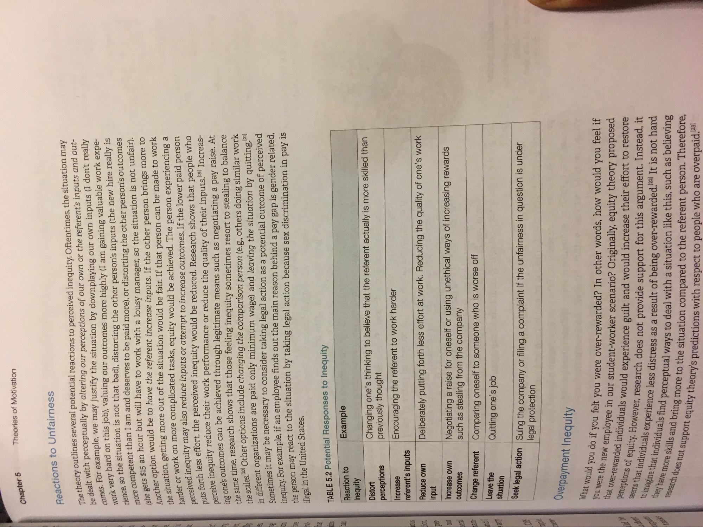
Theories of Motivation
Chapter 5
Reactions to Unfairness
work very hard on rience, so the site
Another option wou
99
theory outlines several potential reactions to perceived inequity. Oftentimes, the situation may dealt with perceptually by altering our perceptions of our own or the referent's inputs and outmes. For example, we may justify the situation by downplaying our own inputs (I don't really
mo hard on this job), valuing our outcomes more highly (I am gaining valuable work expec so the situation is not that bad), distorting the other person's inputs (the new hire really is
mpetent than I am and deserves to be paid more), or distorting the other person's outcomes ats $15 an hour but will have to work with a lousy manager, so the situation is not unfair).
option would be to have the referent increase inputs. If the other person brings more to Gestion, getting more out of the situation would be fair. If that person can be made to work er or work on more complicated tasks, equity would be achieved. The person experiencing a
dinequity may also reduce inputs or attempt to increase outcomes. If the lower paid person Carth less effort, the perceived inequity would be reduced. Research shows that people who
inequity reduce their work performance or reduce the quality of their inputs. Increashe's outcomes can be achieved through legitimate means such as negotiating a pay raise. At
me time, research shows that those feeling inequity sometimes resort to stealing to balance a les 1201 Other options include changing the comparison person (e.g., others doing similar work Tiffarent organizations are paid only minimum wage) and leaving the situation by quitting. Cometimes it may be necessary to consider taking legal action as a potential outcome of perceived
uity For example, if an employee finds out the main reason behind a pay gap is gender related,
erson may react to the situation by taking legal action because sex discrimination in pay is illegal in the United States.
a
8 ho 8
TABLE 5.2 Potential Responses to Inequity
Example
Reaction to Inequity
Distort perceptions
Changing one's thinking to believe that the referent actually is more skilled than previously thought Encouraging the referent to work harder
Increase referent's inputs
Deliberately putting forth less effort at work. Reducing the quality of one's work
Reduce own input Increase own
outcomes
Negotiating a raise for oneself or using unethical ways of increasing rewards such as stealing from the company Comparing oneself to someone who is worse off Quitting one's job
Change referent Leave the
situation
legal action Suing the company or filing a complaint if the unfairness in question is under
legal protection
Overpayment Inequity
What would you do if you felt you you were the new employee in that over-rewarded individuals would ex perceptions of equity. However, research seems that individuals experience to imagine that individuals find perces they have more skills and bring more to research does not support equity theo
do if you felt you were over-rewarded? In other words, how would you feel if mployee in our student-worker scenario? Originally, equity theory proposed
uals would experience guilt and would increase their effort to restore ever, research does not provide support for this argument. Instead, it Erience less distress as a result of being over-rewarded.22. It is not hard ind perceptual ways to deal with a situation like this, such as believing
113 more to the situation compared to the referent person. Therefore, uty theory's predictions with respect to people who are overpaid.

